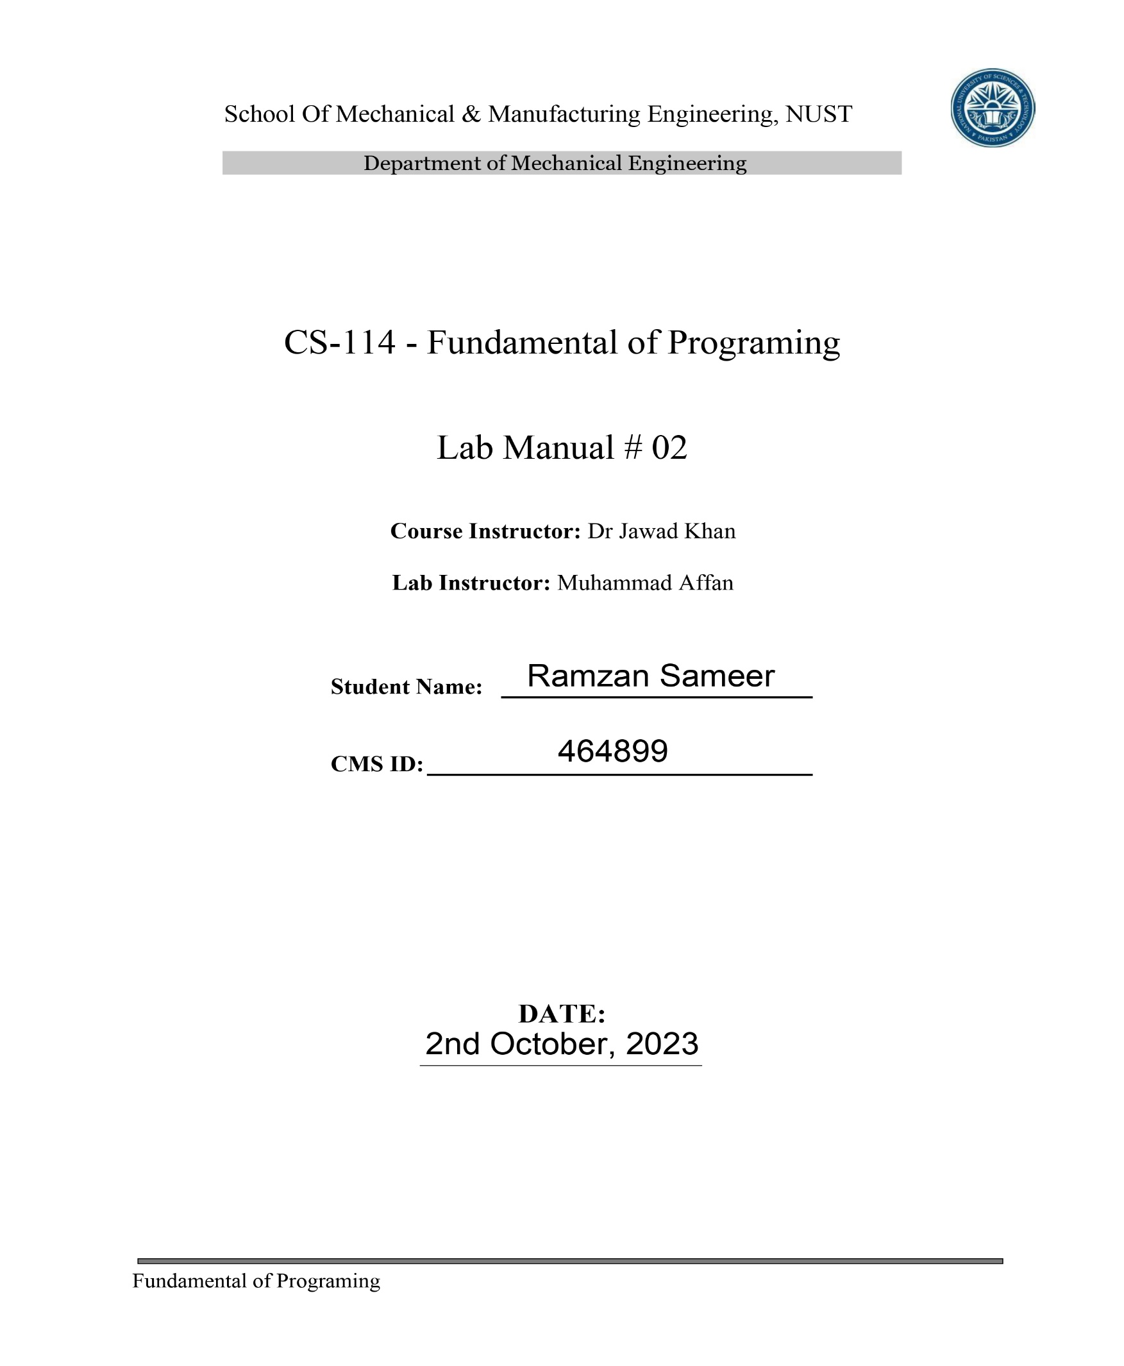

Q1. Write a C++ program to print the total number of populations in Punjab, Sindh, KPK, and Balochistan using a switch case

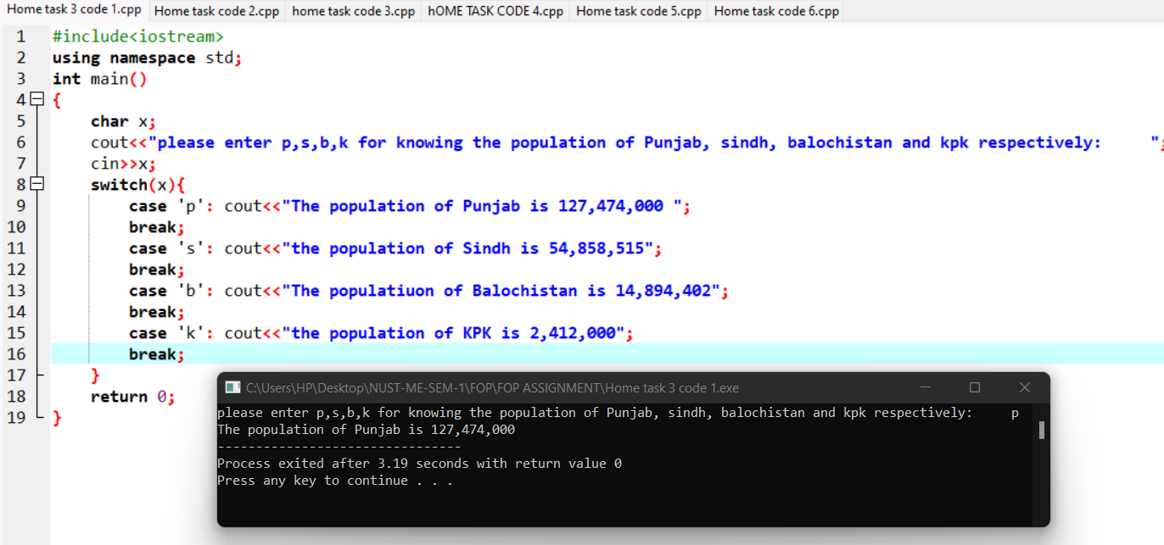

Q2. Write a C++ program to check whether an alphabet is a vowel or consonant using a switch case.

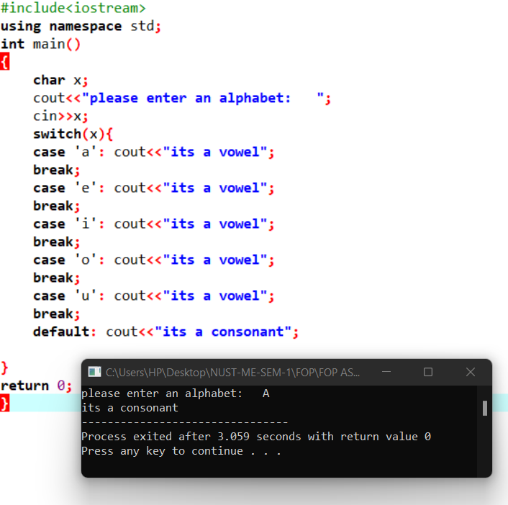

Q3. Write a C++ program to check whether a number is positive, negative, or zero using a switch case.

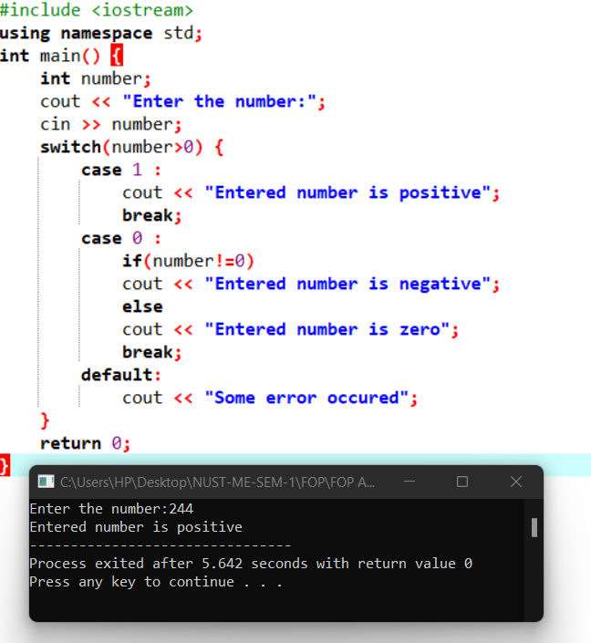

Q4. Write a C++ to find out whether a person is an adult, teenager, or child using nested if-else.

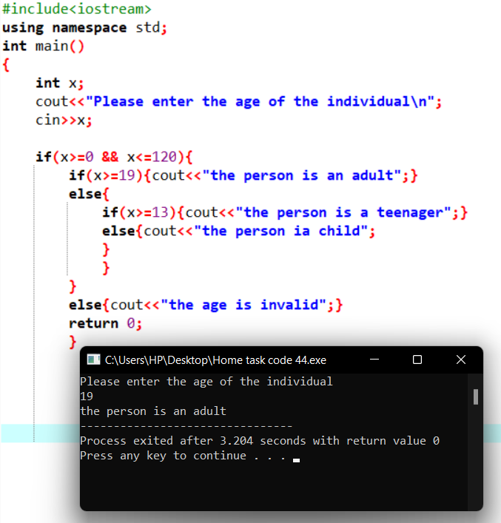

Q5. Write a C++ program that takes three number from the user and find the greatest number out of the three numbers using nested if-else statements.

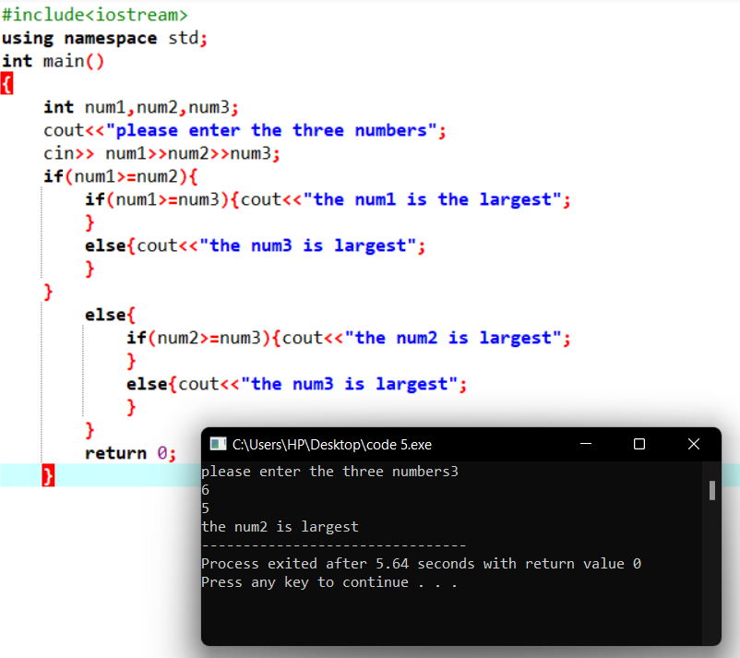

Q6. Write a C++ program to check whether the alphabet entered by the user is Vowel or Consonant using nested if-else.

